June 2026

☐ 1 Job 21–24 ☐ 16 Psalms 62–68
☐ 2 Job 25–30 ☐ 17 Psalms 69–72
☐ 3 Job 31–34 ☐ 18 Psalms 73–77
☐ 4 Job 35–38 ☐ 19 Psalms 78–80
☐ 5 Job 39–42 ☐ 20 Psalms 81–88
☐ 6 Psalms 1–8 ☐ 21 Psalms 89–94
☐ 7 Psalms 9–17 ☐ 22 Psalms 95–103
☐ 8 Psalms 18–21 ☐ 23 Psalms 104–106
☐ 9 Psalms 22–27 ☐ 24 Psalms 107–111
☐ 10 Psalms 28–33 ☐ 25 Psalms 112–118
☐ 11 Psalms 34–37 ☐ 26 Psalm 119
☐ 12 Psalms 38–42 ☐ 27 Psalms 120–133
☐ 13 Psalms 43–49 ☐ 28 Psalms 134–140
☐ 14 Psalms 50–55 ☐ 29 Psalms 141–150
☐ 15 Psalms 56–61 ☐ 30 Proverbs 1–3
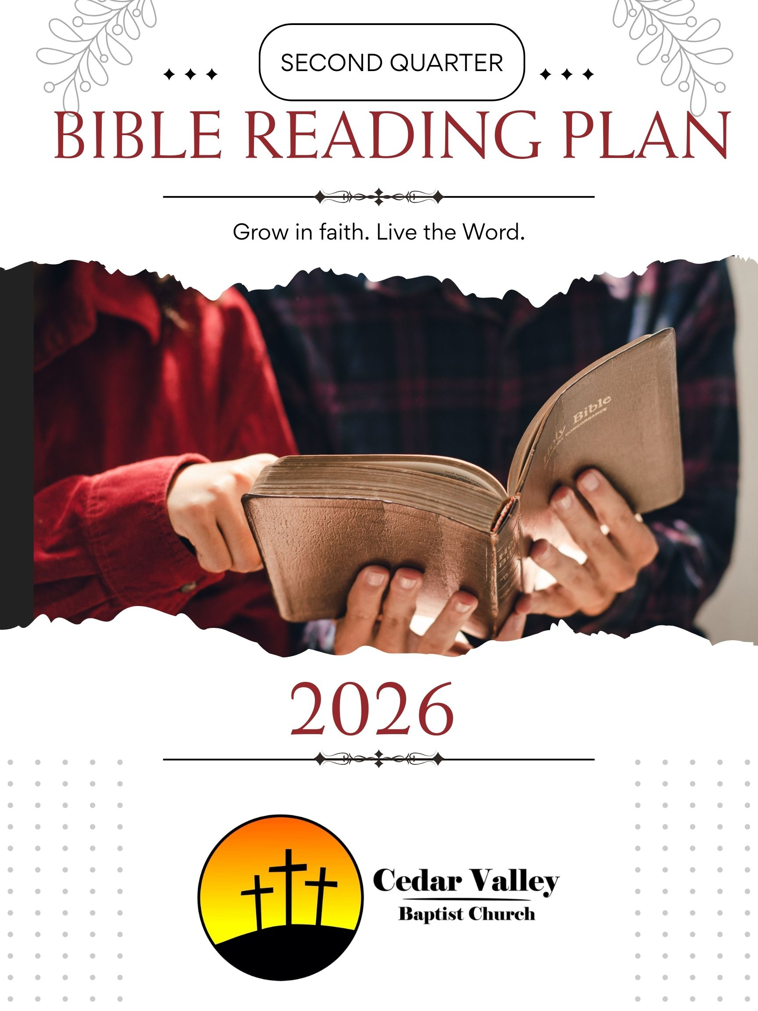
April 2026

☐ 1 2 Samuel 1–3 ☐ 17 1 Kings 21–22
☐ 2 2 Samuel 4–7 ☐ 18 2 Kings 1–3
☐ 3 2 Samuel 8–11 ☐ 19 2 Kings 4–5
☐ 4 2 Samuel 12–13 ☐ 20 2 Kings 6–8
☐ 5 2 Samuel 14–16 ☐ 21 2 Kings 9–10
☐ 6 2 Samuel 17–19 ☐ 22 2 Kings 11–13
☐ 7 2 Samuel 20–22 ☐ 23 2 Kings 14–16
☐ 8 2 Samuel 23–24 ☐ 24 2 Kings 17–18
☐ 9 1 Kings 1–2 ☐ 25 2 Kings 19–21
☐ 10 1 Kings 3–5 ☐ 26 2 Kings 22–23
☐ 11 1 Kings 6–7 ☐ 27 2 Kings 24–25
☐ 12 1 Kings 8–9 ☐ 28 1 Chronicles 1–2
☐ 13 1 Kings 10–12 ☐ 29 1 Chronicles 3–4
☐ 14 1 Kings 13–15 ☐ 30 1 Chronicles 5–6
☐ 15 1 Kings 16–18
☐ 16 1 Kings 19–20

May 2026

☐ 1 1 Chronicles 7–9 ☐ 17 2 Chronicles 35–36
☐ 2 1 Chronicles 10–12 ☐ 18 Ezra 1–4
☐ 3 1 Chronicles 13–16 ☐ 19 Ezra 5–7
☐ 4 1 Chronicles 17–19 ☐ 20 Ezra 8–10
☐ 5 1 Chronicles 20–23 ☐ 21 Nehemiah 1–3
☐ 6 1 Chronicles 24–26 ☐ 22 Nehemiah 4–7
☐ 7 1 Chronicles 27–29 ☐ 23 Nehemiah 8–10
☐ 8 2 Chronicles 1–4 ☐ 24 Nehemiah 11–13
☐ 9 2 Chronicles 5–7 ☐ 25 Esther 1–5
☐ 10 2 Chronicles 8–11 ☐ 26 Esther 6–10
☐ 11 2 Chronicles 12–16 ☐ 27 Job 1–4
☐ 12 2 Chronicles 17–20 ☐ 28 Job 5–8
☐ 13 2 Chronicles 21–24 ☐ 29 Job 9–12
☐ 14 2 Chronicles 25–28 ☐ 30 Job 13–16
☐ 15 2 Chronicles 29–31 ☐ 31 Job 17–20
☐ 16 2 Chronicles 32–34

